Relational Database Project Proposal

Group Members: Federico Balestri, Nicola Barsanti, Riccardo Bertini, Mirco Quintavalla

Introduction

Our proposal for an application based on a relational database consists in the development of a software designed to meet the data management requirements of a fictional tech company named *Innovative Solutions*, whose core business is the assembly of electronic and mechanical components into consumer-grade products (e.g. remotes or smart light bulbs).

Working Hypotheses

The design of the relational database will be based upon the following working hypotheses:

* *Customers* may purchase any *Products* up to their available quantity
* Each *Employee* in the company may belong to up to one *Team*
* *Teams* are assigned to the assembly of the *Products* offered by the company, where each Product is assembled by a single team
* *Products* are composed of one or more *Components*
* *Components* are purchased from a list of *Suppliers*, where different suppliers may offer the same component at different prices

Software Architecture

The application will consist in a front-end module written in Java which through a graphical interface allows the company’s system administrators to connect and perform a list of predefined and parametrized operations upon an underlying MySQL database.

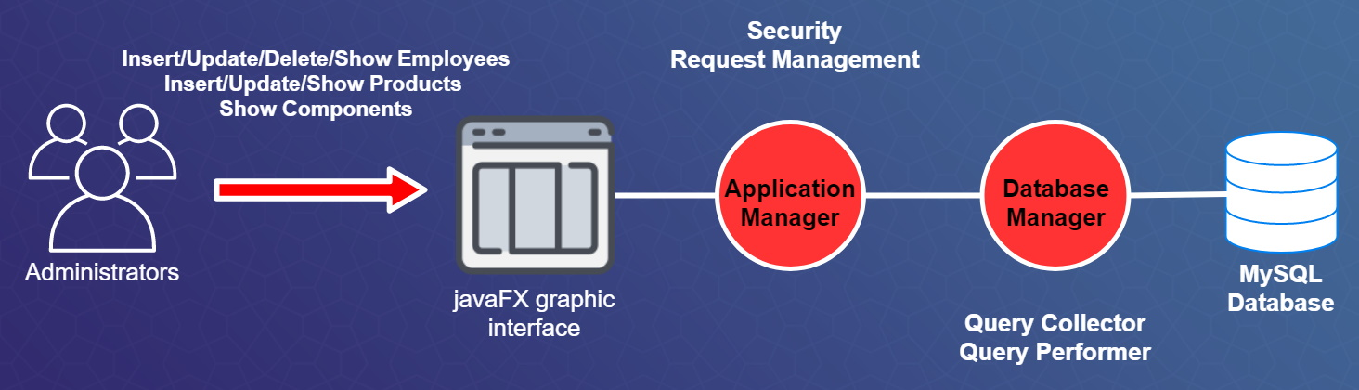

Software Functionalities

Through the use of the graphical interface, the system administrators will be able to perform the following operations on the database:

* Set or change the Team an Employee belongs to
* Insert a new Employee
* Insert a new Product
* Delete an Employee
* Delete a Team
* Show the currently available Products
* Show the currently available Components
* Edit a Product’s information